**Sign up for GitHub**

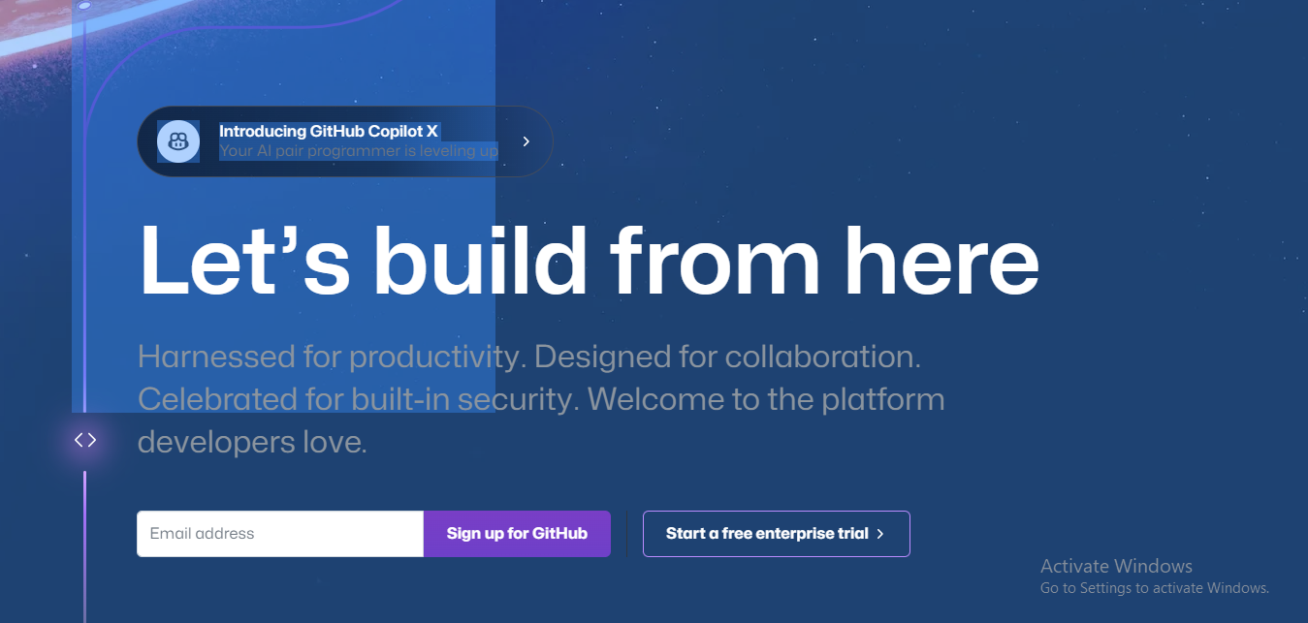

**Create an GitHub Account**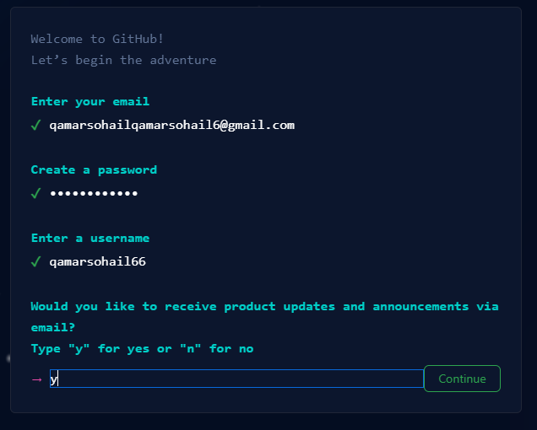

**Enter a username and Verify your Account**

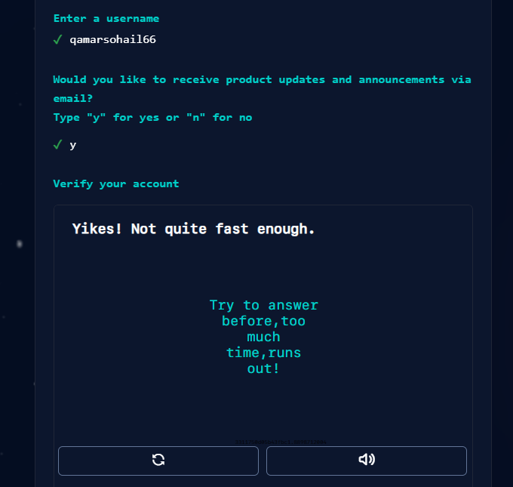

Student1@DESKTOP-MT0UR2V MINGW64 ~ (master)

$ pwd

/c/Users/Student1

Student1@DESKTOP-MT0UR2V MINGW64 ~ (master)

$ ls

'3D Objects'/ Favorites/ NTUSER.DAT{9b713543-b2b7-11ed-9ca8-a08cfde2dd7a}.TxR.0.regtrans-ms OneDrive/ Templates@

AppData/ IntelGraphicsProfiles/ NTUSER.DAT{9b713543-b2b7-11ed-9ca8-a08cfde2dd7a}.TxR.1.regtrans-ms Pictures/ Videos/

'Application Data'@ Links/ NTUSER.DAT{9b713543-b2b7-11ed-9ca8-a08cfde2dd7a}.TxR.2.regtrans-ms PrintHood@ akhuwatfoundation/

Contacts/ 'Local Settings'@ NTUSER.DAT{9b713543-b2b7-11ed-9ca8-a08cfde2dd7a}.TxR.blf Recent@ ntuser.dat.LOG1

Cookies@ MicrosoftEdgeBackups/ NTUSER.DAT{9b713544-b2b7-11ed-9ca8-a08cfde2dd7a}.TM.blf 'Saved Games'/ ntuser.dat.LOG2

Desktop/ Music/ NTUSER.DAT{9b713544-b2b7-11ed-9ca8-a08cfde2dd7a}.TMContainer00000000000000000001.regtrans-ms Searches/ ntuser.ini

Documents/ 'My Documents'@ NTUSER.DAT{9b713544-b2b7-11ed-9ca8-a08cfde2dd7a}.TMContainer00000000000000000002.regtrans-ms SendTo@ 'opera autoupdate'/

Downloads/ NTUSER.DAT NetHood@ 'Start Menu'@

Student1@DESKTOP-MT0UR2V MINGW64 ~ (master)

$ cd Desktop/

Student1@DESKTOP-MT0UR2V MINGW64 ~/Desktop (master)

$ cd Qamar

Student1@DESKTOP-MT0UR2V MINGW64 ~/Desktop/Qamar (master)

$ git init

Initialized empty Git repository in C:/Users/Student1/Desktop/Qamar/.git/

Student1@DESKTOP-MT0UR2V MINGW64 ~/Desktop/Qamar (master)

$ git status

On branch master

No commits yet

Untracked files:

(use "git add <file>..." to include in what will be committed)

index.html

script.js

style.css

nothing added to commit but untracked files present (use "git add" to track)

Student1@DESKTOP-MT0UR2V MINGW64 ~/Desktop/Qamar (master)

$ git add -A

Student1@DESKTOP-MT0UR2V MINGW64 ~/Desktop/Qamar (master)

$ git commit -m 'I am Qamar'

[master (root-commit) caae6b3] I am Qamar

3 files changed, 0 insertions(+), 0 deletions(-)

create mode 100644 index.html

create mode 100644 script.js

create mode 100644 style.css

Student1@DESKTOP-MT0UR2V MINGW64 ~/Desktop/Qamar (master)

$ git remote add origin 'https://github.com/qamarsohail66/qamar.git'

Student1@DESKTOP-MT0UR2V MINGW64 ~/Desktop/Qamar (master)

$ git push origin master

Enumerating objects: 3, done.

Counting objects: 100% (3/3), done.

Delta compression using up to 4 threads

Compressing objects: 100% (2/2), done.

Writing objects: 100% (3/3), 239 bytes | 239.00 KiB/s, done.

Total 3 (delta 0), reused 0 (delta 0), pack-reused 0

To https://github.com/qamarsohail66/qamar.git

* [new branch] master -> master

Student1@DESKTOP-MT0UR2V MINGW64 ~/Desktop/Qamar (master)

$

